# Literature Survey

The demand of solar collectors has increased drastically in the past decade, as the world is striving to harvest cleaner and more sustainable forms of energy. The drive toward solar energy is approaching a climax at a very high rate, especially in regions of the world where there are a lot of sunny days. Public awareness campaigns are launched everywhere, and it seems that the world consumers are slowly starting to move away from electrical geysers. According to H. Aktamis (2011) the level of awareness of renewable energy sources is very among the general public, especially among second grade students in the developed countries of the world.

Solar power is readily useable in South Africa, with applications including: photovoltaic (PV) cells; domestic and swimming pool heating for the middle and upper class; industry applications; agriculture; and pumping of water in rural areas (Dept. of Energy, 2016). South Africa has an ideal climate for solar power applications with a lot of sunshine days, as well as a lot of daylight hours. Data from ClimaTemps (2016) can be seen in Figure 1.

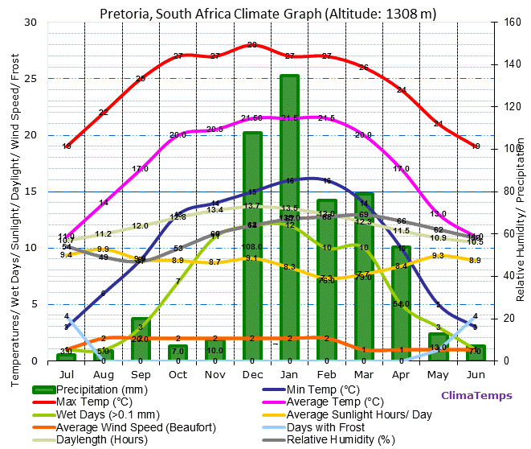

Solar water heating systems can be active or passive. Active systems contain a pump or fluid moving device, that enables circulation of the heat storage fluid, between the storage tank and the collector. Passive systems rely on gravity or the natural convective tendency of a big bulk of water to circulate and spread the heat. Most systems that heat water with solar radiation are active systems. The two most common active type solar collectors are the evacuated tube collectors and the flat plate collectors. There are also a lot of different designs for flat plate collectors. The design used in this project has copper tubing that runs through the absorber plate, and therefore heats up the fluid running through the tube. This is depicted in Figure 1.

: 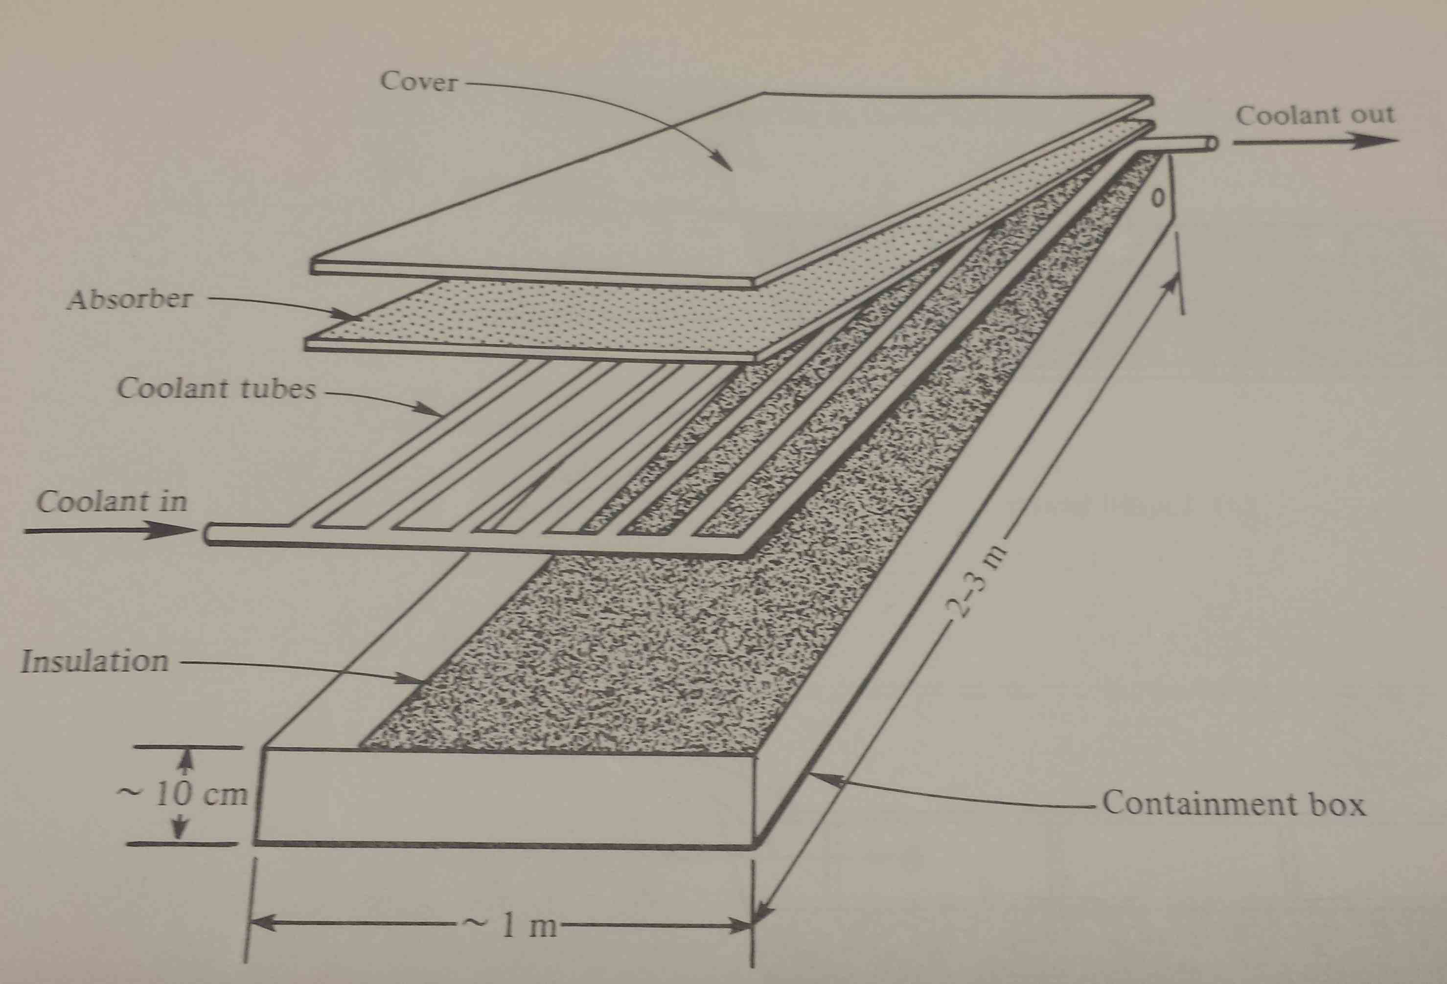

**Figure 1:** The layout and design of the flat plate solar collector used.

Flat plate solar collectors are mostly designed for energy delivery at moderate temperatures (up to 100 ⁰C above ambient temperature). These collectors convert both beam and diffuse radiation from the sun and do not need a lot of maintenance. Another advantage of these collectors is that they do not require solar tracking (tracking can be implemented at a loss of overall panel efficiency, or a very small gain in efficiency) (Duffie & Beckman, 2006). These units are mechanically and thermally a lot simpler the evacuated tube type collectors.

Despite the physical design of the collector, there are a multitude of other conditions to consider when modelling or setting up a solar collector. A few of these conditions include: the average wind speed and direction; the effective radiation available for absorption by the collector; the materials of the collector plate, cover, and insolation; and the mean difference in angle between the normal plane of the collector and the Direct Normal Irradiance (DNI).

## Average Wind Speed and Direction

In order to minimise the heat loss through, the solar panel should preferably lie in a direction where the glass/polymer cover, gets the least amount of wind exposure. In Figure 2, the hourly wind speed and direction over the course of one year (2016) is displayed (data from SAURAN, 2016). The wind speed and direction appears to be very evenly distributed, with no obvious configuration coming to mind.

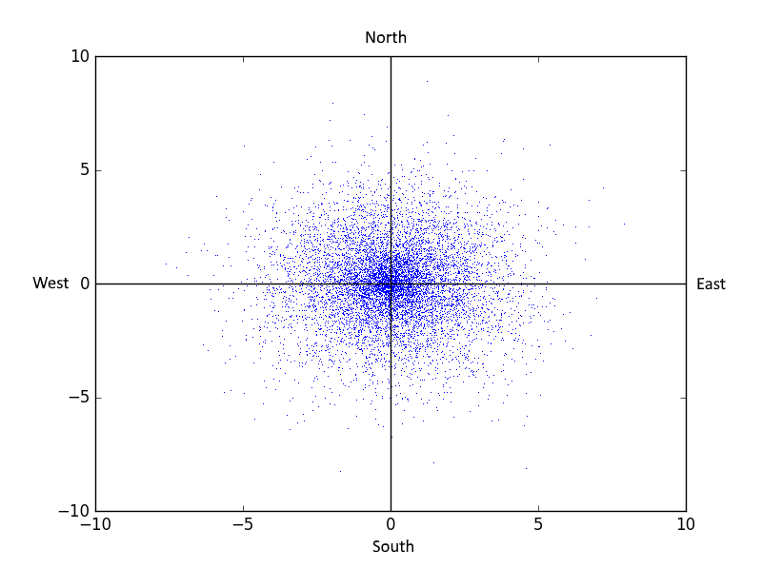

**Figure 2:** A wind speed and direction distribution for Pretoria, South Africa.

The most notable observation in Figure 2, is the low average wind velocity (a mere 2 m/s). This is very advantageous for setting up a solar farm in the Pretoria region.

## Effective Radiation

Radiation from the sun is the most resource of energy for the earth. There are however a multitude of factors to consider when calculating, or describing the heat from the sun. Because the sun’s light contains a lot of wavelengths or spectrums, the heat absorbed by different materials may vary according to ability of the material to absorb as large a spectrum of light as possible. Mostly these effects are lumped into the absorption and emission coefficients of materials.

Due to the rotation of the earth and its movement around the sun, the sun does not radiate toward earth at a constant angle. In the summer months of a region the sun will shine at an almost 90 ⁰ angle with the horizontal at noon. This angle will change in the winter season of the same region. This is better illustrated in Figure 1 (Duffie & Beckman, 2006).

For simplicity in modelling there are a few types of irradiations that are measured. They are the Direct Normal Irradiance (DNI), the Diffuse Horizontal Irradiance (DHI), and the Global Horizontal Irradiance (GHI).

## Materials and Construction of a Collector

### Glass Cover

The glass cover’s (usually made of tempered or toughened glass) purpose is to protect the rest of the collector from environmental effects, while at the same time allowing radiation to strike the absorber plate. Usually the glass used is very transparent, allowing more than 90% of the incident radiation to pass through.

### Absorber Plate

Made from a thin sheet of aluminium, with a coating of a highly selective material that is very efficient at absorbing solar radiation, the absorber plate’s main purpose is to convert the incident radiation to effective heat that can be transferred to the water (or another working fluid). The welding between the copper pipes and the aluminium sheet is usually done ultrasonically, in order to weld joint with very low thermal resistance.

### Insolation

The insolation’s, usually made from ultra-light weight melamine foam, function is to minimize the heat loss through the back of the absorber plate. Newer flat plate models use a vacuum as insolation (AEE INTEC).

### Riser and Header Pipes

Made from copper, these tubes are welded ultrasonically in order to minimize heat loss over the weld joints. Further functions of these tubes are to transfer the stored/converted heat to the working fluid. Small riser pipe diameters contribute to turbulent flow through the pipe, maximizing the convective heat transfer within the pipes.

Further detail regarding the physical and heat transfer parameters of all the relevant materials can be found in Appendix B.

## Thermal Network of the Collector

The easiest way to conceptualize the heat transfer within a flat plate solar collector is to draw up a thermal resistance network. This can be seen in Figure 2.

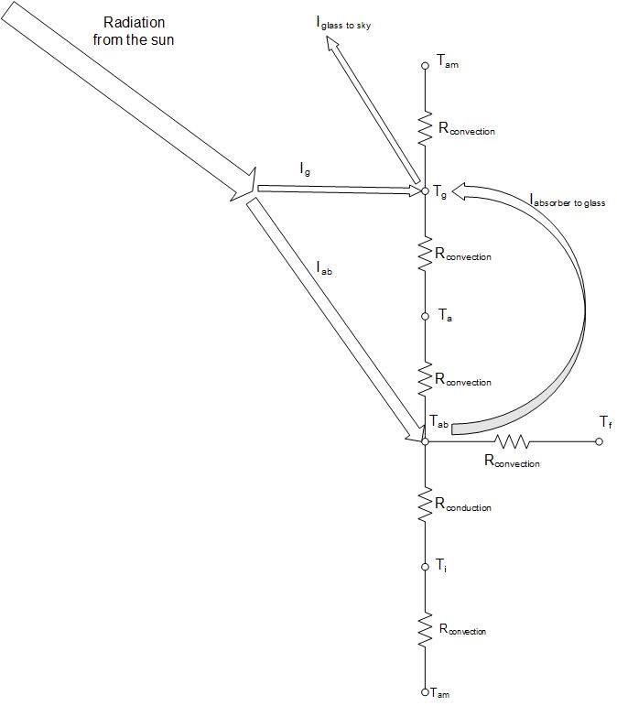

While resistances were not actually used to set up the model, the resistance network still holds as a very convenient way to illustrate the system. The convective and conductive ‘resistances’, were only used to in order to calculate the heat flux, by using the common transfer function for heat transfer

|  |  |  |
| --- | --- | --- |
|  |  | () |

The equation describing the thermal resistance to convection is

|  |  |  |
| --- | --- | --- |
|  |  | () |

whereas the equation describing thermal resistance to conduction is

|  |  |  |
| --- | --- | --- |
|  |  | () |

(Ḉengel & Ghajar, 2011). For more information regarding the heat transfer coefficients refer to Section ?? and Appendix ??.

## Radiation heat flow

In this model, it was assumed that the emitted radiation from the glass panel and the absorber plate was substantial. The other components’ radiative effects were assumed to be negligible.

The radiative heat flux from the glass panel to the sky, can be described by

|  |  |  |
| --- | --- | --- |
|  |  | () |

(Ḉengel & Ghajar, 2011), where the sky temperature is given by Swinbank’s formula

|  |  |  |
| --- | --- | --- |
|  |  | () |

(Saleh, 2012).

Radiation from the absorber plate is toward the glass plate, and can be calculated using the formula

|  |  |  |
| --- | --- | --- |
|  |  | () |

(Goswami *et al*, 2000).

All of the radiation constants can be seen in Appendix ??.

## Convective heat transfer coefficients

Multiple convective heat transfer coefficients are needed for the model. All of these equations are from Ḉengel & Ghajar (2011).

Firstly, the forced external convection coefficient of all the surfaces (the glass panel as well as the back of the collector) can be calculated, assuming there is a certain wind speed, by

|  |  |  |
| --- | --- | --- |
|  |  | () |

where

|  |  |  |
| --- | --- | --- |
|  |  | () |

for laminar flow and

|  |  |  |
| --- | --- | --- |
|  |  | () |

for turbulent flow. The Nusselt number described above are average Nusselt number over the whole plate region. A fluid with a Reynolds number of less than $5×{10}^{5}$ is considered to be laminar, while the moment the Reynolds number is larger than this number, the flow is considered to be turbulent, as the general assumption is that there is no transitional region between laminar and turbulent flow. The Reynolds number for external flow over a flat plate can be expressed as

|  |  |  |
| --- | --- | --- |
|  |  | () |

When considering forced internal convection in the insides of the riser pipes, the following expressions can be used to calculate the convective heat transfer coefficient. The Reynolds number can be calculated using

|  |  |  |
| --- | --- | --- |
|  |  | () |

It is again assumed that there is no transitional region between laminar and turbulent flow. Flow is considered to be laminar when the Reynolds number is less than $2000$, while a Reynolds number higher than this number will indicate turbulent flow. The convective heat transfer coefficient can then be calculated by

|  |  |  |
| --- | --- | --- |
|  |  | () |

for laminar flow (with the assumption of a constant surface temperature) and

|  |  |  |
| --- | --- | --- |
|  |  | () |

for turbulent flow, where $n=0.4$ for heating and $n=0.3$ for cooling applications.

The air pocket inside the collector is susceptible to natural convection from the glass plate as well as the absorber plate. The plates were assumed to be perfectly horizontal. The Rayleigh number should be calculated as

|  |  |  |
| --- | --- | --- |
|  |  | () |

where

|  |  |  |
| --- | --- | --- |
|  |  | () |

The Rayleigh number can then be used to calculate the convective heat transfer coefficient using

|  |  |  |
| --- | --- | --- |
|  |  | () |

for heat loss from the upper surface of a hot plate (the absorber plate) and

|  |  |  |
| --- | --- | --- |
|  |  | () |

for heat loss from the bottom surface of a hot plate (the glass cover). In Equation (16) and Equation (17) $L_{n}$ can be calculated with

|  |  |  |
| --- | --- | --- |
|  |  | () |

## Efficiency of a Collector

Due to time-related factors, two efficiencies are defined for a flat plate solar collector. These efficiencies are the instantaneous and average efficiencies. The instantaneous efficiency is simply

|  |  |  |
| --- | --- | --- |
|  |  | () |

(Goswami *et al*, 2000). The average efficiency can be defined as

|  |  |  |
| --- | --- | --- |
|  |  | () |

(Duffie & Beckman, 2006). In both cases

|  |  |  |
| --- | --- | --- |
|  |  | () |

## Assumptions in Model

* Uniform mass flow in collector tubes
* One-dimensional heat transfer
* No heat transfer in the direction of the flow
* No heat transfer or heat loss from the edges of the collector
* All thermal properties are independent of temperature
* Heat loss through the front and the back are to the same ambient temperature
* The sky can be considered as a black body for radiation at an equivalent sky temperature
* No dust and dirt on the collector panel

## A few previous models

A dynamic model of a flat plate solar collector was set up by Saleh (2012), as part of a Master of Science in Engineering thesis. In the model, a partial volume approach is used, solving the time differential in several nodes, serving as the length dependant differential. Nearly all of the heat transfer calculations were done using Duffie & Beckman (2006) as a guideline. The maximum error over two two-hour testing periods was 4.5 %. His model performed a lot worse in windy conditions, than in still atmosphere conditions. The efficiency of the collector was not calculated.

Gunjo & Mahanta (2016) set up a Computational Fluid Dynamics (CFD) model for a single riser tube for steady state conditions. This study was very thorough, and different temperature profiles for the length across a riser pipe, the cross-sectional area of the riser pipe, and the insolation adjacent to a riser pipe was generated using Ansys. The absorption and heat transfer efficiencies for absorber plates of different materials (copper, aluminium, and steel) were determined and compared. The model could predict the steady state outlet temperature with a maximum relative error of 5.4%. Aluminium was recommended as the best absorber material, since the perdormance of copper, was only marginally bigger than that of aluminium.

Hung *et al* (2016) set up a CFD model, using Solar Ray Tracing as a method for thermal radiation flux boundary layer analysis. The purpose was to harness thermal energy more effectively using the principles of solar ventilation technology and a solar air collector. They concluded that an inverse proportionality exists between the outlet temperature and efficiency, and the emissivity of the material used in the construction of a solar collector.

# References

Duffie, JA and Beckman WA (2006) *Solar Engineering of Thermal Processes*, John Wiley & Sons, Hoboken.

Goswami, DY, Kreith, F and Kreider, JF (2000) *Principles of Solar Engineering*, Taylor & Francis, New York.

Howell, JR, Bannerot, RB and Vliet, GC (1982) *Solar-Thermal Energy Systems*, McGraw-Hill, New York.

Saleh, AM (2012) *Modelling of Flat-Plate Solar Collector Operation in Transient States*, Masters of Science Thesis, Purdue University, Fort Wayne, United States of America.

Hung, T, Huang, T, Lee, D, Lin, C, Pei, B and Li, Z (2016) “Numerical analysis and experimental validation of heat transfer characteristic for flat-plate solar air collector” *Applied Thermal Engineering*, 111(2017), 1025 – 1038.

Gunjo, DG, Mahanta, P and Robi, PS (2016) “CFD and experimental investigation of flat plate solar water heating system under steady state condition” *Renewable Energy*, 106(2017), 24 – 36.